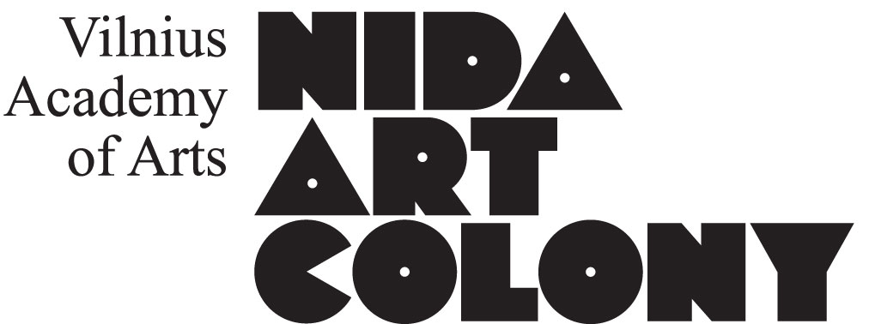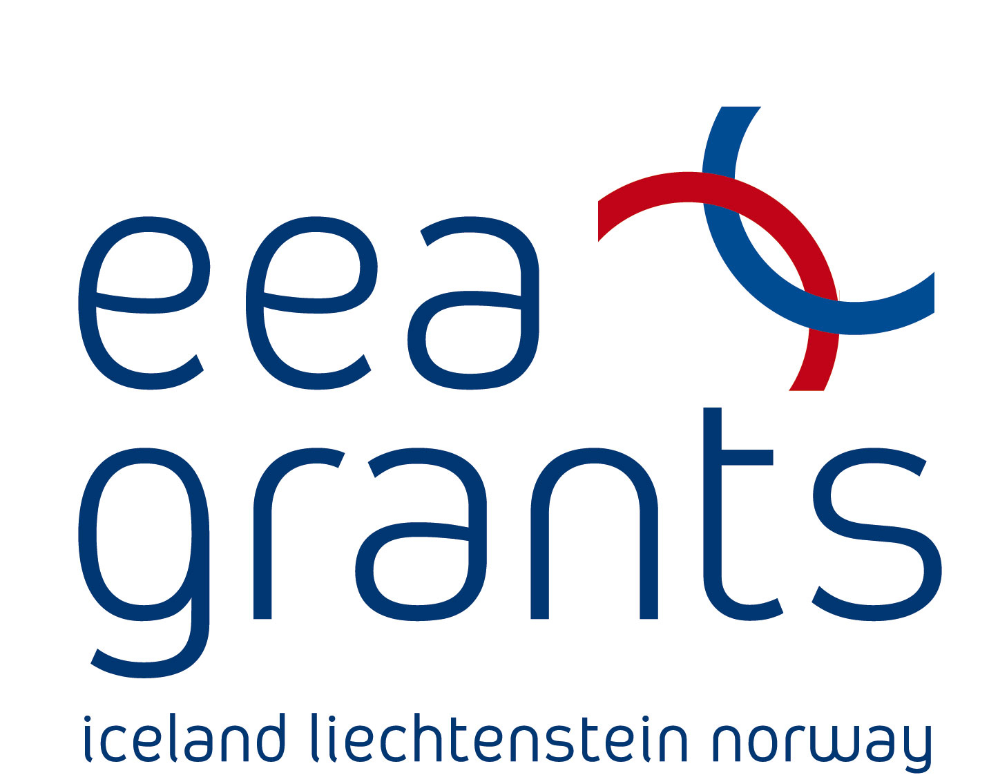

Application for Climbing Invisible Structures: August 2015 – April 2016
Family name:
First name:
Nationality:
Date of birth:
Address  (place of residence): | Street:  City:  Country:  ZIP code:
Telephone number:
Email address:
Website:
Affiliated organization (if any):
Preferred residency locations and periods (please, mark the numbers in order of priority) | Artists from Norway and Iceland:  1 2 Ars Communis Residency Centre YO-YO, 2 residencies: August-  September 2015  1 2 Nida Art Colony, 4 residencies: October-November 2015  Artists from Lithuania:  1 2 3 Nordic Artists’ Centre Dale, 2 residencies: August-September 2015  1 2 3 Office for Contemporary Art Norway, 1 residence: October-November 2015  1 2 3 Skaftfell Center for Visual Art, 1 residence: October-November 2015
Language proficiency | English:  Fluent □ Advanced □ Intermediate □ Beginner □
Artist statement
(if you take part in the project it will be published on the partners’ web sites, max. 200 words)
Attachments | □ CV  □ Portfolio  □ Description of a project for Climbing the Invisible (max 500 words)  (Application documents should be combined into one pdf/doc file.)

All applications are to be sent by email to info@nidacolony.lt
Please do not send files more than 10 MB. If you have larger files please zip them or send by online file sharing service (for ex. www.wetransfer.com).

Deadline 24 May 2015

For more information on the programme’s content, please, write to the curators: Eglė Mikalajūnė egle@ndg.lt and Samir M’kadmi s-mkad@online.no

For more information on the practical aspects of the programme, please write to the project manager Rasa Antanaviciute rasa.antanaviciute@vda.lt

The programme is financed by the European Economic Area Financial Mechanism 2009-2014 and NAC.

